**02. Deploy Metrics Server and Sample Application**

--- Reference - <https://github.com/stacksimplify/aws-eks-kubernetes-masterclass/tree/master/15-EKS-HPA-Horizontal-Pod-Autoscaler>

**Introduction**

* What is Horizontal Pod Autoscaling?
* How HPA Works?
* How HPA configured?

--- the above, we learned in previous lecture.

**Install Metrics Server**

**# Verify if Metrics Server already Installed**

--- **kubectl -n kube-system get deployment/metrics-server**



--- note – metric server is not installed.

**# Install Metrics Server**

--- kubectl apply -f <https://github.com/kubernetes-sigs/metrics-server/releases/download/v0.3.6/components.yaml>

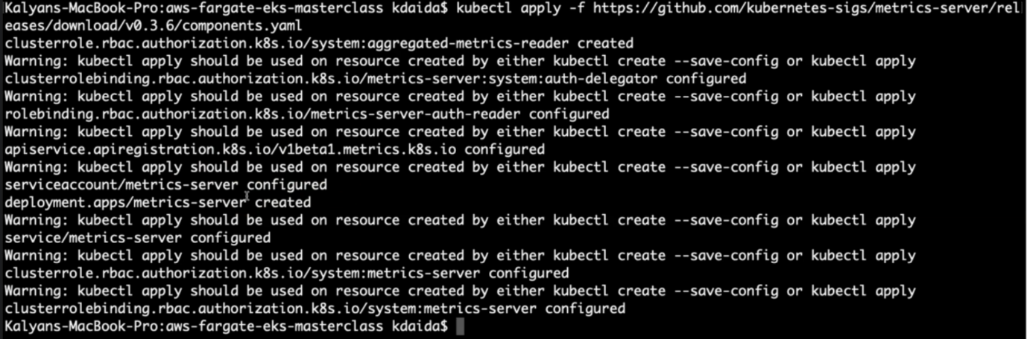

--- **note** – metric server is installed.

**# Verify**

--- **kubectl get deployment metrics-server -n kube-system**

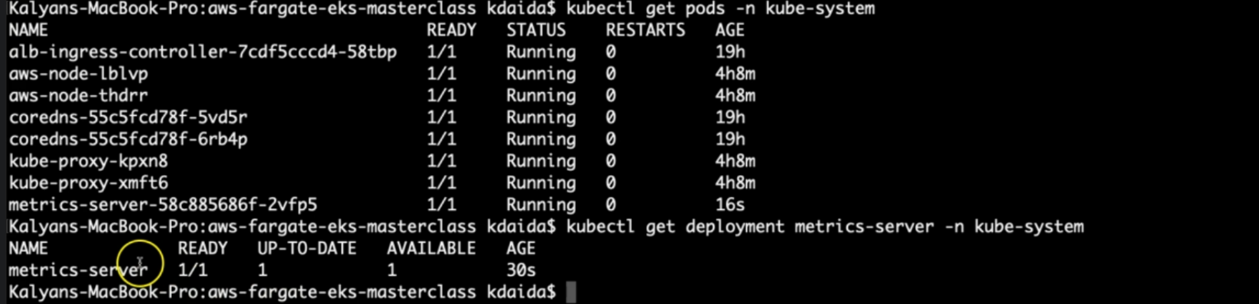

--- **note** – the metric server deployment is successful.

**Review Deploy our application**

--- **01-HPA-Demo.yml**

apiVersion: apps/v1

kind: Deployment

metadata:

  name: hpa-demo-deployment

  labels:

    app: hpa-nginx

spec:

  replicas: 1

  selector:

    matchLabels:

      app: hpa-nginx

  template:

    metadata:

      labels:

        app: hpa-nginx

    spec:

      containers:

      - name: hpa-nginx

        image: stacksimplify/kubenginx:1.0.0

        ports:

        - containerPort: 80

        resources:

          requests:

            memory: "128Mi"

            cpu: "100m"

          limits:

            memory: "500Mi"

            cpu: "200m"

---

apiVersion: v1

kind: Service

metadata:

  name: hpa-demo-service-nginx

  labels:

    app: hpa-nginx

spec:

  type: NodePort

  selector:

    app: hpa-nginx

  ports:

  - port: 80

    targetPort: 80

    nodePort: 31231

**# Deploy**

--- **kubectl apply -f kube-manifests/**

**# List Pods, Deploy & Service**

--- **kubectl get pod,svc,deploy**

**# Access Application (Only if our Cluster is Public Subnet)**

--- **kubectl get nodes -o wide**

--- **http://<Worker-Node-Public-IP>:31231**

